**Junior manual QA engineer**

**Serhii Zahrebelnyi**

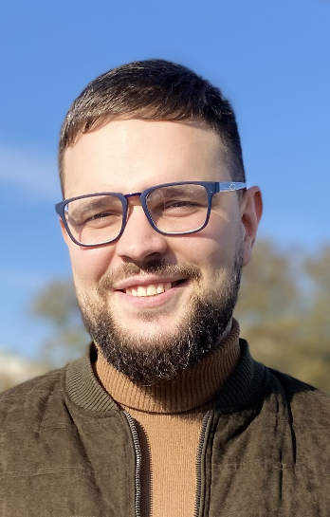**8.02.1991**

**Location:** Kharkov, Ukraine

**Phone:** +380963629433

**E-mail:** zahrebelnyi.s@gmail.com

**LinkedIn:** <https://www.linkedin.com/in/serhii-zahrebelnyi-3a61a9166/>

**Education**

**2021:** Courses of Testing (QA) + SCRUM on Lemon.School (2 months of practical training + theory)

**2008-2013:** Specialist of Mariupol State University (Management)

**Skills**

**TESTING SKILLS:**

Create test artefact (Bug report, test case, check list)

Jira/TestRail (familiar with applications)

MySQL (sent requests CREATE, DROP, SELECT, ALTER, INSERT)

POSTMAN (sent requests POST, GET, PUT, DELETE)

HTML/CSS (created website by video lesson)

**SOFT SKILLS:** Team work, friendly.

**LANGUAGE SKILLS:** English (Pre-Intermediate).

**INTEREST:** English, frameworks for testing.